***Bicycle watch with 2 faces***

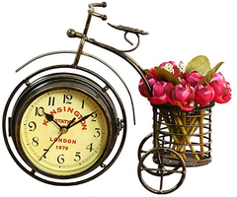

*The double-sided bicycle watch is made of metal material. There are 2 independent timers. Use 2A battery. Products suitable as gifts for boyfriends, girlfriends, colleagues, or gifts for parents, family members ...*